­­­­­­­­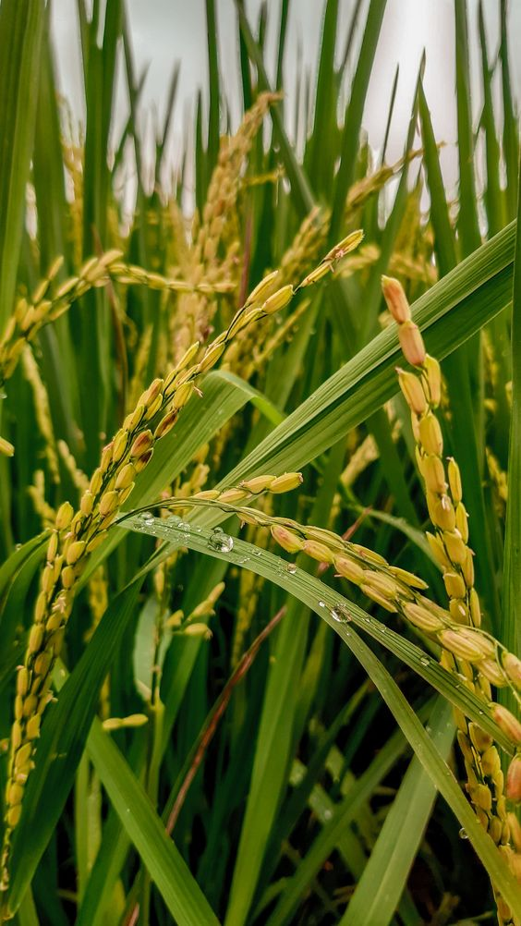

**INDIA’S AGRICULTURE CROP PRODUCTION ANALYSIS**

***Indian_agriculture_NM2023TMID00060***

***PROJECT DOCUMENTATION***

● Define Problem / Problem Understanding

* Specify the socialproblem
* Literature Survey
* Social Impact

● Data Collection & Extraction

* Collect the dataset
* Connect DB with Tableau

● Data Preparation

* Prepare the Data for Visualization

● Data Visualizations

* No of Unique Visualizations

● Dashboard

* Responsive and Design of Dashboard

● Story

* Prepare the conclusion

● Publishing

* Publishing Dashboard and Story to tableau public

● Project Demonstration & Documentation

* Record explanation Video for project end to end solution

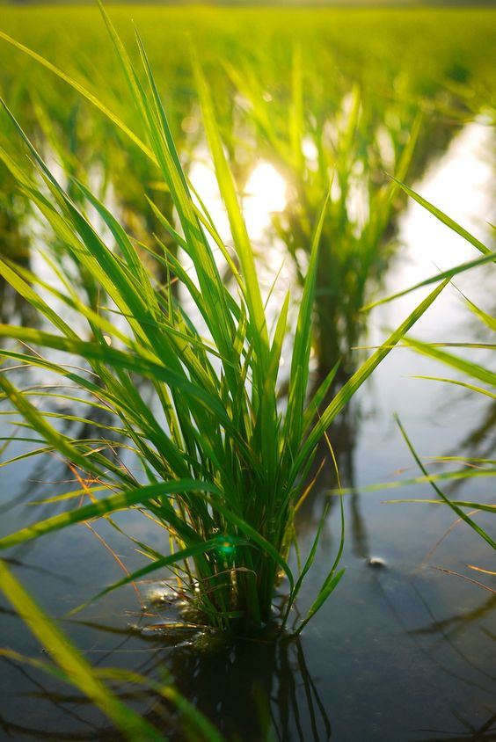***INTRODUCTION:***

***In a topic ‘INDIA’S AGRICULTURE CROP PRODUCTION ANALYSIS’ we may conclude about the present situation of crops cultivation.To choose this topic aims to create awarenwss about agriculture that is headed towards the extinction of agriculture. It is the process that initites the flow towards the agriculture which is the‘BACKBONE’ of India.***

***DEFINE A PROBLEM:***

* ***Empathy map***

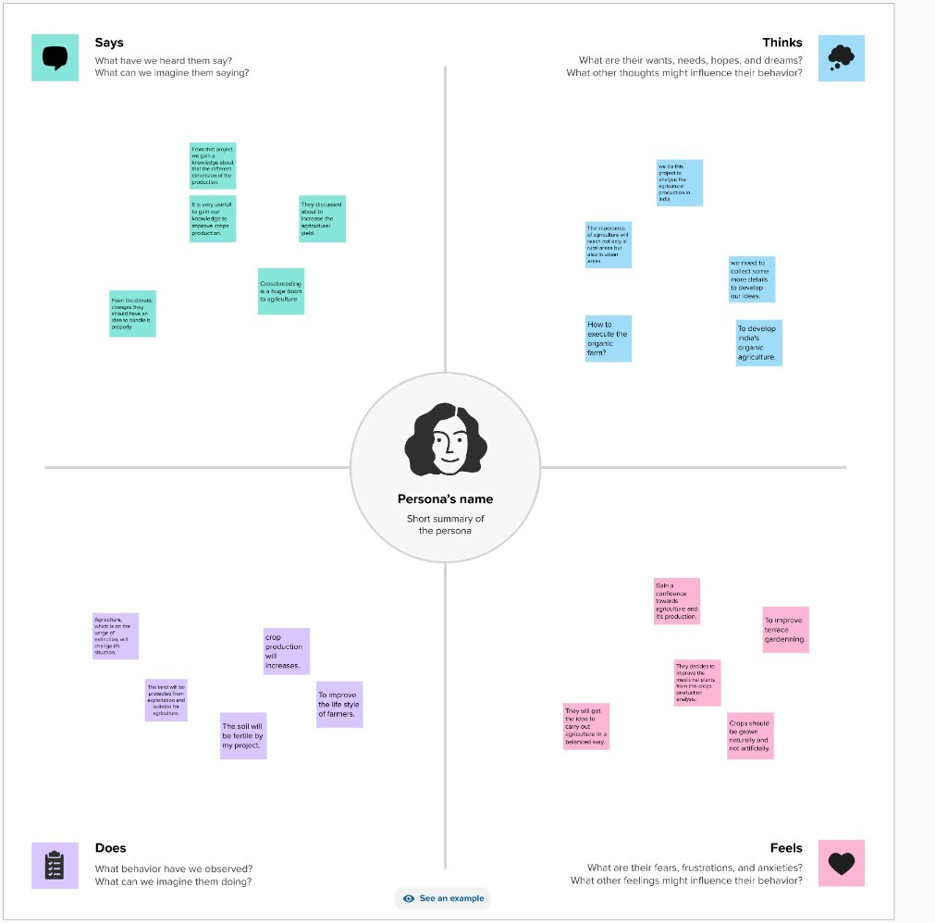

***This Empathy map shows that the queries like climatic conditions, finanfial problems, and pollutant problems like problems about agriculture towards the farmers. It is the brief explanation of the project.It provides an information about our project.***

* ***Brain storming map***

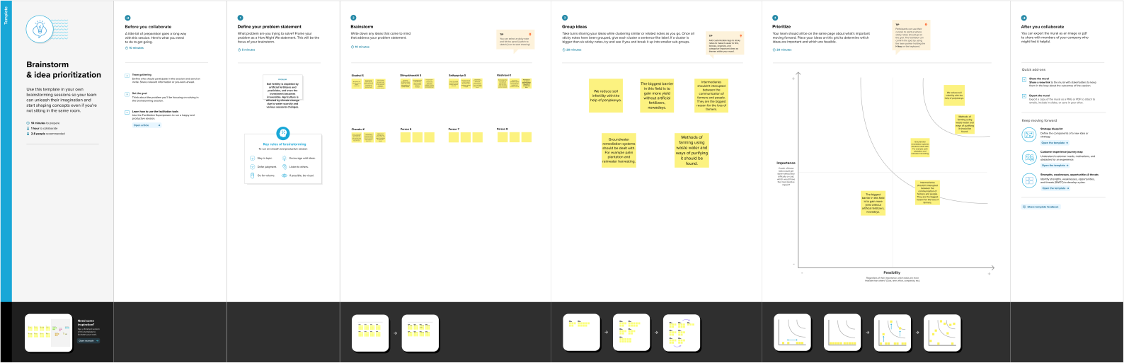

***This Brain storming map explains about the problems that occurring in agriculture clearly. And it helps us to solve those problems that contains in crop cultivation at present situation.***

***DATA VISUALIZATIONS:***

***From the following visualizations we have the deep conclusion about the agriculture.***

***To build those visualizations firstly we need to connect the given data set.***

***VISUALIZATION I***

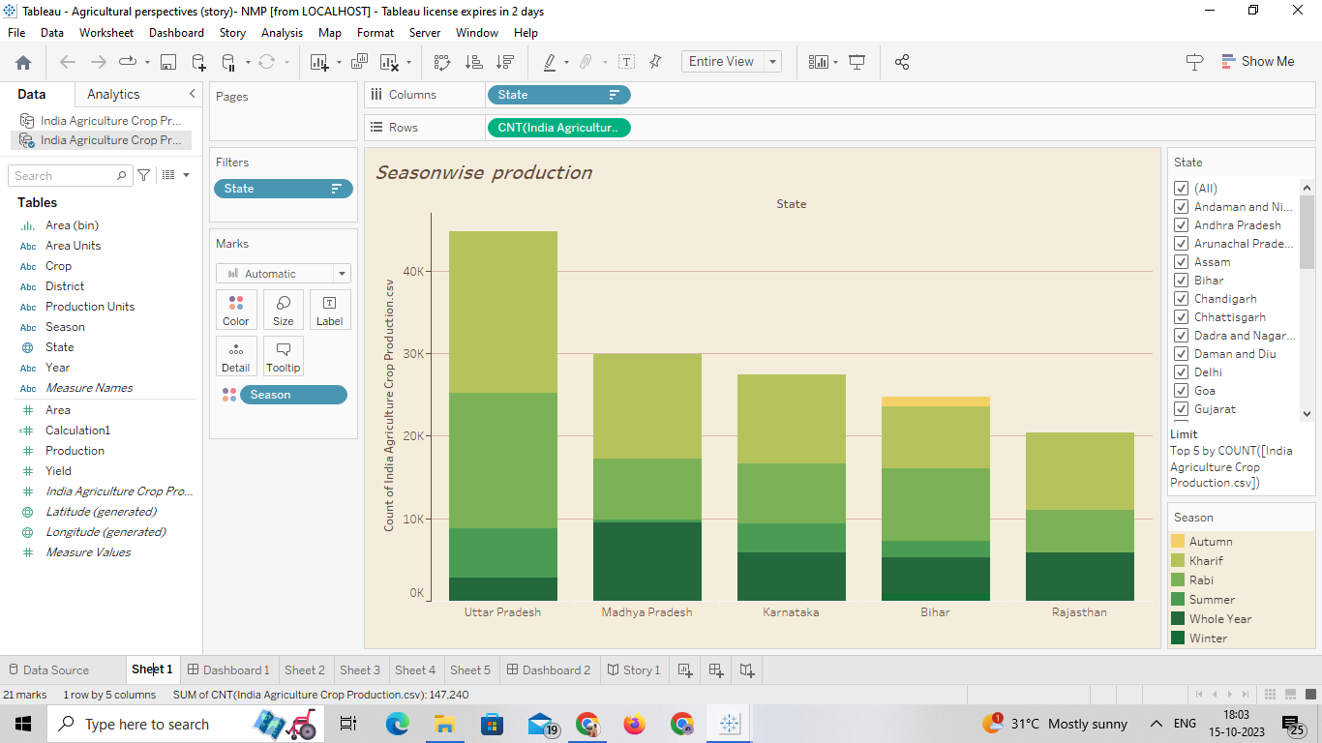

***SEASON WISE PRODUCTION fig. 1(Visualization – I)***

***From this visualization we have to conclude the yield in season wise production.And Utterpradesh has more production rates based on states. During the autumn season Bihar is the only state that made a cultivation.***

***VISUALIZATION II & III***

***This particular visualization two shows the total agricultural land providing by states. And the third visualization explains about the total area in the same states.***

***It shows that the land mass is one of the reason for the yield.***

***And it has an conclusion that providing only minute changes.***

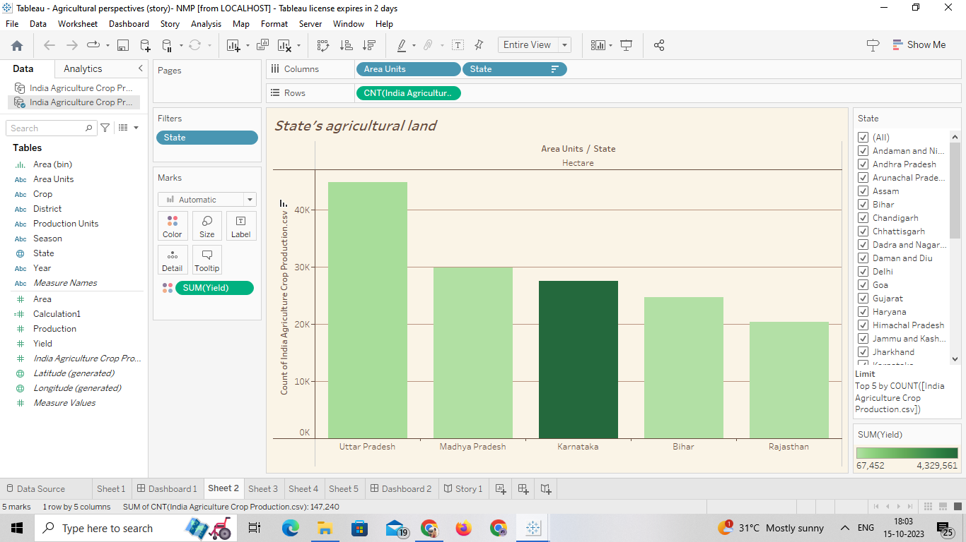

***STATE’S AGRICULTURAL LAND*** ***fig. 2(Visualization – II)***

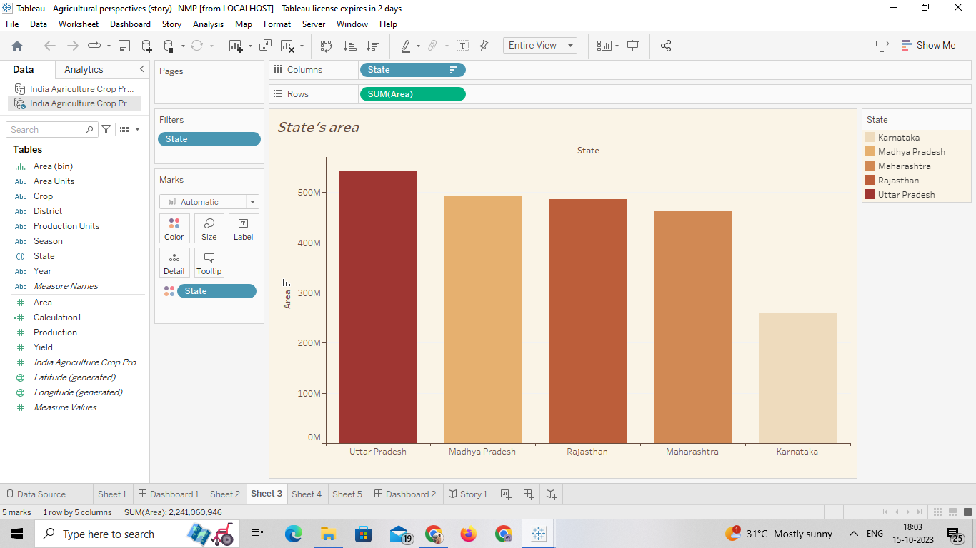

***STATE’S AREA fig. 3(Visualization – III)***

***VISUALIZATION IV***

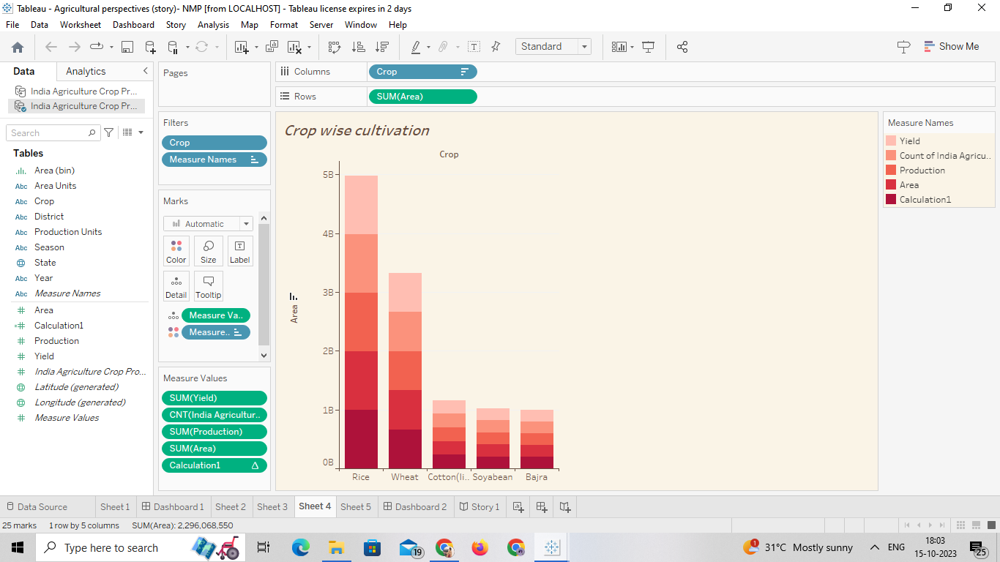

***CROP WISE CULTIVATION fig. 4(Visualization – IV)***

***From this visualization we have to explains that the crop wise cultivation. According to the given data, Rice is the crop which people need a lot.So it shows the demand and expectations of the people.***

***It shows the demand from the people, orderly***

* ***Rice***
* ***Wheat***
* ***Cotton***
* ***Soyabean***
* ***Bajra***

***VISUALIZATION IV***

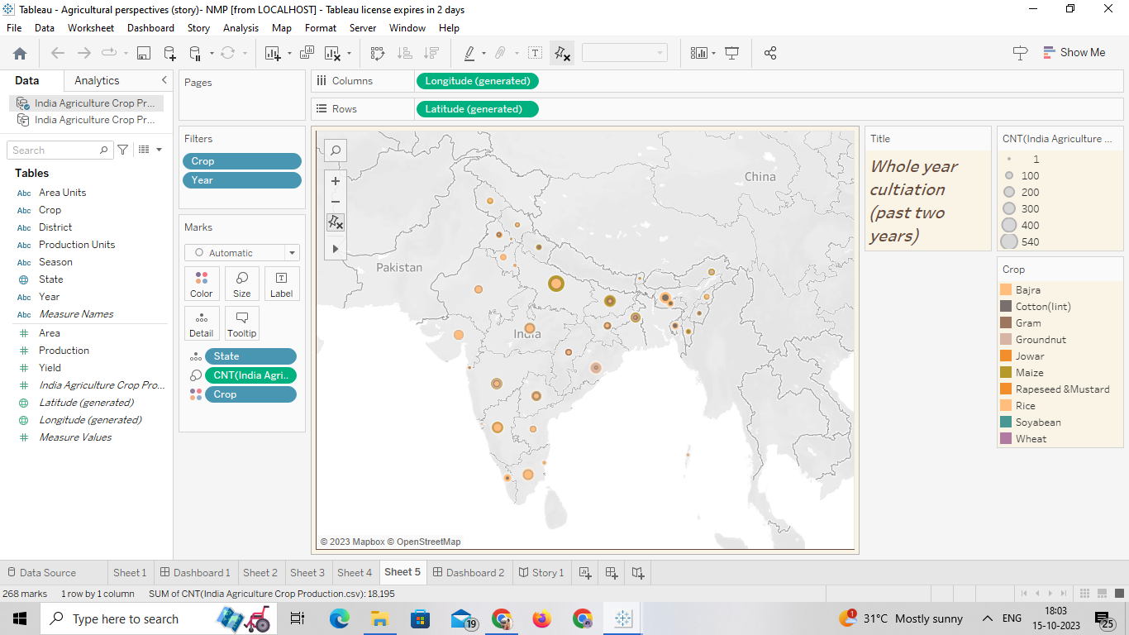

***WHOLE YEAR CULTIVATION – Past two years fig. 5(Visualization – V)***

*This map shows the cultivation during past two years in the given data.*

*These all five visualizations shows the major needs and also the major problems that contained in the given data.*

*DASHBOARD:*

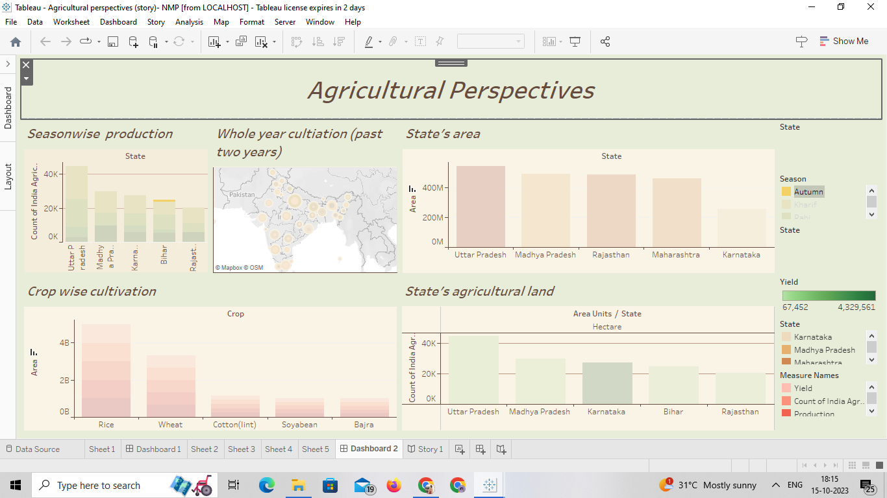

*STORY:*

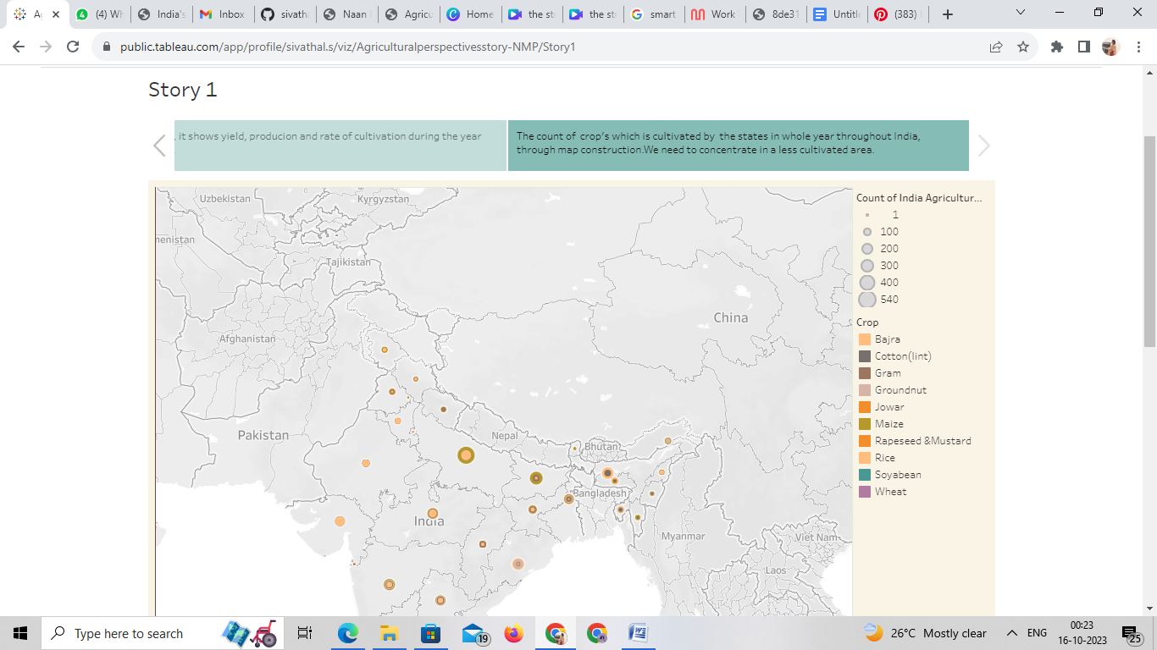

SCOPE:

Agriculture is the good for the future as it is expected to use advanced technologies and innovations to produce more food with limited land and resources ,increase efficiency on farms ,and become more profitable, efficient,safe and environment friendly.

CONCLUSION:

The agricultural sector is of vital importance for the region.It is undergoing a process of transition to a market economy ,with substantial changes in the social ,legel ,structural,productive supply set -ups ,as is the case with all other sectors of the economy

***THANK YOU***